Given the root of a binary tree, return *its maximum depth*.

A binary tree's **maximum depth** is the number of nodes along the longest path from the root node down to the farthest leaf node.

**Example 1:**

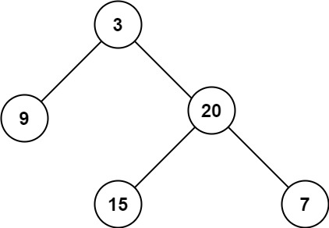

**Input:** root = [3,9,20,null,null,15,7]

**Output:** 3

**Example 2:**

**Input:** root = [1,null,2]

**Output:** 2

**Constraints:**

* The number of nodes in the tree is in the range [0, 104].
* -100 <= Node.val <= 100